International Women’s Day of Prayer
March 05, 2016

“Daring to Ask for MORE!”
(Four Divine Keys to Abundant Spiritual Blessings)

Written by
Melody Mason

Edited by: Carolyn Kujawa



Prepared by the General Conference of Seventh-day Adventists
Women’s Ministries Department

Table of Contents

Introduction ________________________________ 3

About the Author ______________________________________________4

Prayer Requests, Divisions/Areas of the World: SID, NAD, MENA ______________________ 5

Suggested Order of Service _____________________________________________________ 8

Children’s Story: “When God used Elephants to Answer Prayer ___________________ 9

Sermon: “Daring to Ask for More: Four Divine Keys to Abundant Spiritual Blessings” 12

Afternoon/Evening Prayer Program Ideas 26

- Program Idea #1: “The Circle of Blessings – Prayer Program”
- Program Idea # 2: “Standing in the Gap – Prayer Program”
- Program Idea # 3: “Agape Thanksgiving Banquet – Prayer Program”



November 24, 2015

Dear Sisters:

Do you pray enough? Many of us can answer “No” to this question. Many of us desire a deeper and more meaningful prayer experience with God. The question is, “How many of us are willing to do all it takes to have a deeper and more meaningful prayer life and closer walk with God?” This year’s International Day of Prayer packet is titled “Daring to Ask for More.” It challenges each of us to ask God for a better prayer life and to boldly ask for His blessings in our lives in areas of need. Our need may be spiritual, financial, health-related, or many other concerns. As children of God we need to remember that God is willing and able to fulfill our needs, especially when we cry out for a closer relationship with Him.

Our author for this resource packet is Melody Mason, a woman of God and a faithful and powerful prayer warrior. She understands the desire that many of us have as we seek for a better relationship with God, and in her sermon she explains how we can achieve this. But we must each ask ourselves, “Are we willing to do all it takes to have a deeper and more meaningful prayer life and closer walk with God?”

John writes, “…I pray that you may prosper in all things and be in health, just as your soul prospers” 3 John 1:2. It is our prayer for you that on this day of prayer emphasis that we will all make a commitment to enable our souls to prosper so we can be in good health spiritually.

Blessings and joy to you,

Heather-Dawn Small
Director

About the Author

Melody Mason, also known as Melodious Echo, has a passion for prayer and for helping people to develop a genuine walk with Jesus. Besides working with ARME Bible Camp Ministries and assisting with prayer ministries in the Arkansas-Louisiana Conference, she also leads prayer initiatives for the General Conference’s Annual Council and other official church events. Melody loves hiking, writing, volunteering in overseas missions, and photography. When not traveling the world, Melody can be found at home with her family on the farm where she grew up, in the Ozarks of Arkansas.

Prayer Requests
Divisions/Areas of the World to be Remembered in Prayer

Southern Africa-Indian Ocean Division (SID)

Territory: Angola, Botswana, Comoros, Lesotho, Madagascar, Malawi, Mauritius, Mayotte, Mozambique, Namibia, Reunion, Sao Tome and Principe, Seychelles, South Africa, Swaziland, Zambia, Zimbabwe, and Ascension, St. Helena, and Tristan da Cunha Islands; comprising the Botswana, Indian Ocean, Malawi, North Zambia, South Zambia, Southern Africa, and Zimbabwe Union Conferences; the Mozambique, North-Eastern Angola, and South-Western Angola Union Missions; and the Sao Tome and Principe Mission.

Requests (submitted by Joanne Ratsara)

- Please pray that the women of SID, both young and experienced, will pray for the infilling of the Holy Spirit and be Godly women, ready to lovingly serve in both the church and the community.

2. Please pray that the women of SID will be given, and will accept, opportunities to further their education, thereby enabling them to reach their full potential.

3. The SID is growing fast. Please pray that God will raise up more godly female leaders among the ranks of the churches within SID. More Godly women are needed in leadership roles in all areas of society. There are already gifted and talented women leading in government, education, healthcare and business. More Godly female leaders are in church ministries, helping lead Africa into a new era of progress, positive growth, and significant Christian influence.

4. Please pray that the women of SID will be godly mothers, wives and daughters, filling the special role God has given them in their homes.

5. Please pray that the women of SID will be positive examples in their communities as they model Christian life-styles, by encouraging and modeling loving relationships, purpose-filled lives, good health, industry, happy marriages and happy families.

6. Please pray that the women of SID will participate in the One Member One Soul evangelism initiative.

7. Please pray for unity among the women of SID as they focus on the mission of the church.

8. Please pray that the Six Critical Issues, barriers which prevent many women from reaching their potential, will be addressed so that women may fill a larger role in the mission of the church.
North American Division (NAD)
Territory: Bermuda, Canada, the French possession of Saint Pierre and Miquelon, the United States of America, the United States territories of Guam and Wake Island, the Federated States of Micronesia, Johnston Island, Marshall Islands, Midway Islands, Northern Mariana Islands, and Palau; comprising the Atlantic, Seventh-day Adventist Church in Canada, Columbia, Lake, Mid-America, North Pacific, Pacific, Southern, and Southwestern Union Conferences; and the Guam-Micronesia Mission.

Requests (submitted by Melody Mason)

1. That God will put a hedge around each woman in NAD and will protect their marriages, their children, and their ministries from the attacks of Satan.
2. That each woman will share the Hope we have in Jesus and His soon return with a fearful and dying world.
3. That ministries of compassion will be an ongoing part of Women’s Ministries in each church and conference, including ministering to abused women and their children.

Middle East and North Africa (MENA)

Territory: Lebanon, Iraq, Jordan, Iran, Turkey, N. Cyprus, Morocco, Algeria, Tunisia, Libya, Egypt, Sudan, Saudi Arabia, Yemen, Oman, United Arab Emirates, Bahrain, Qatar and Kuwait

Requests (submitted by Jaimie Eckert & Kathie Lichtenwalter, assistants to secretary of MENA)

- Please pray for the women WITHIN the Middle East or of Middle Eastern heritage to dedicate their lives to mission in the culture that is familiar and understood. The spiritual connection INTO the Middle Eastern family (both Muslim and otherwise) is very often through the women and their children.

- Pray that the women of MENA not only have a sense of personal calling from God, but that God will also provide scholarship funding to support them in getting an education.

- Pray for the refugee crisis in the MENA territory, which is affecting countless women, many of whom are widows struggling to support large families. Pray also that this displacement will open hearts of both men and women to hearing the gospel.

- Pray for the women who are victims of sexual abuse, that God will provide a way out and provide leaders working to prevent violence against women.

Suggested Order of Divine Worship Service

Women’s Ministries Day of Prayer
March 5, 2016

Prelude
Platform participants enter
Doxology
Invocation
Offertory
Offering Response
Offertory Prayer
Hymn: “Standing on the Promises” [#518]

Children’s Story: “When God Used Elephants to Answer Prayer”

Scripture Reading: Jer. 33:3

“Call unto me, and I will answer thee, and shew thee great and mighty things, which thou knowest not” (Jer. 33:3, KJV).

Intercessory Prayer
Special Music
SERMON: “Daring to Ask for More: Four Divine Keys to Abundant Spiritual Blessings.”

Closing Congregational Hymn: “There Shall be Showers of Blessings” [#195]

Benediction & invitation to Afternoon Prayer Program
Postlude

CHILDREN’S STORY
“When God Used Elephants to Answer Prayer”

[If possible, have a globe or map to show children where Zambia is. Try to have toy elephants to use at the appropriate time in the story.]

How many of you have ever prayed to God about something, and not long after God answered your prayer? Maybe it was to find a lost toy, or to help your mommy or daddy feel better. Or maybe it was so that you would do better in school and not get in trouble. Yes! Many of us have seen God answer our prayers.

But did you know that sometimes God might even use animals to answer a prayer?

Today I want to tell you a story about how God used elephants to answer someone’s prayer.

A little while back there was a village in Northern Zambia that decided that people who were Seventh-day Adventists were not welcome in their village.

Seventh-day Adventist missionaries would go to this village to tell them about Jesus, but they didn’t want to learn about Jesus, so the missionaries were always rudely sent away. This happened year after year.

Finally it was decided to send what is called a Global Pioneer missionary family to live in that village. This family were strong believers in prayer. So, not knowing what they would find, this family, who we will call the “Jeremiahs,” moved to the village.

However, when they arrived, none of the villagers would give them a place to stay. Because of this, they had to spend the night outside under the stars. Night after night they slept outside because the villagers wanted nothing to do with these Seventh-day Adventist missionaries.

Now in some places, sleeping outside under the stars wouldn’t be a problem, but there in Northern Zambia, there were many wild animals, and it really wasn’t safe outside at night. However, the Jeremiahs did not get discouraged. Instead, they kept praying and praying!

Finally, the villagers began to feel sorry for this family and their children, and they decided to give them a place to stay. But they told the Jeremiahs, “Just because we are giving you a place to stay does not mean we want to hear about your God. Keep your Bible to yourselves!”

Oh, the missionaries were happy! At least now they had a house to live in. God was answering their prayers.

However more and more days went by and the villagers still wanted to hear nothing about Jesus. The missionaries wondered, what were they to do?

Finally, Brother Jeremiah, who was a real man of prayer, decided to start preaching to the mentally disturbed people in the village. He found eleven of them, and as he shared with them about Jesus, he began praying that they would be healed. At first the villagers thought he was crazy. Why was he talking to the mentally ill people! He truly was as crazy as they thought!

However, guess what? It wasn’t too long and God heard his prayer. Those eleven mentally disturbed villagers were healed. Brother Jeremiah then began to study the Bible with them and tell them about Jesus. After a while, they decided they wanted to follow Jesus!

Now the people of the village had a real problem! Do you know why they had a real problem? It was because one of the men who was healed had been the village chief a few years ago. And when he was healed and became a Christian, he decided to donate some of his land for Brother Jeremiah and his family to build a church.

Oh no! Oh no! There was no way the villagers wanted this to happen. What were they to do? So the whole village was in an uproar.

As they argued, Brother Jeremiah begin to pray some more. “God, please help us! You brought us here. You healed these people, including this chief. And now you’ve given us land to build a church. Please help us work out this problem.”

Not too long after that, the strangest thing happened. An elephant and her calf decided that they were going to make the piece of land that had been donated for the church their new home.

Now, in case you didn’t know, an elephant with a baby calf can be very dangerous. The mother elephant’s natural instinct is to protect her young. Because of this, the villagers knew that it would now be impossible for brother Jeremiah to build his church on that land. They were rejoicing.

“You see,” they told the chief who had been healed. “Even the elephants know that these people are bad. You must send them away.”

One whole week went by, and when Friday came the villagers whispered among themselves, “Now we will see where these crazy people will worship since the elephants are still on their land.”

Sabbath morning came and, wonder of wonders, the elephant and her calf, of their own free will, got up, moved off the land, and watched from a distance as the new believers came to worship. The stubborn villagers could not believe it, and now the happy believers were the ones rejoicing!

The Seventh-day Adventist missionaries and the people who had been healed worshiped the whole day and praised God for His miracle. Finally, when sunset came, they went back to their houses. And guess what happened when they left. When they left, the elephant and calf came back to their chosen spot on the church property. In fact, no one could do anything with the church property during the week, because the elephant mama and her baby kept it guarded. But when Sabbath came, they once again moved off the property so the believers could worship.

Isn’t this an amazing story?

Not long ago, some leaders from the church headquarters visited this village and found that there are now 90 baptized members of the Seventh-day Adventist church worshiping God here! One of the mentally ill men who was healed is now a deacon of the church.

So you see, sometimes we may face problems that seem impossible, but we serve a God who hears and answers prayers. And sometimes, He even uses a mama elephant and her baby to help answer prayers.

Let’s pray:

Dear Jesus, We thank you that no matter what kind of problems we face, You are bigger than any problem, and You are a God who hears and answers prayers. Help us to trust You, and help us learn how to believe Your Word and not let go until we see You answer our prayers just like Brother Jeremiah did in that difficult village in Zambia. Truly You are an amazing God! We love You! In Jesus’ Name, Amen.

SERMON

Daring to Ask for MORE!
(Four Divine Keys to Abundant Spiritual Blessings)
By Melody Mason

Scripture: “Call unto me, and I will answer thee, and shew thee great and mighty things, which thou knowest not” (Jer. 33:3, KJV).

SLIDE: Title

Good morning and Happy Sabbath! I’m really looking forward to seeing what God has in store for us today as we take some extra time to focus on prayer as a church family.

We just had an opening prayer, but before we begin, since we are talking about the importance of prayer, let’s pray one more time:

Dear Heavenly Father, this morning as we talk about prayer and the divine keys to abundant spiritual blessings, we ask for an extra measure of Your Holy Spirit! We need You to open our ears and open our hearts, and remove any distractions from our mind. Change us, Lord, today, from the inside out! Give us a deeper hunger for You! May we not leave this place the same as we came. May we truly be inspired to dare to ask for more, and as a result, may we experience the abundant spiritual blessings that You have for us. Thank You for hearing this prayer. In Jesus’ precious name, Amen.

SLIDE: Baptism Story
Once there was a man who asked his pastor what it would take for a true Holy Spirit revival to come upon his life. The pastor explained that he would have to baptize the man in order to show him. The man thought this was a bit strange, but he agreed, so they proceeded to the river.

After lowering themselves into the water, the pastor covered the nose of the man and proceeded to gently lay him back under the surface of the water. However, rather than lifting the man back up immediately, the pastor continued to hold him under the water. The man, not sure what was happening, began to struggle a bit; however the pastor’s grip was firm.

After a few moments, panic seized the man, and thinking that maybe the pastor was trying to drown him, he began to thrash and jerk about violently, trying to get free. At this point the pastor brought him back to the surface.

The man, visibly shaken and gasping for breath, stuttered angrily, "What in the world were you trying to do? Did you want to drown me?”

Calmly, the pastor replied, "When you are as desperate for revival as you were just now for that next breath of air, then the Lord will send revival!"

SLIDE QUESTION: So I want to ask you all today: how desperate are you for deeper richer spiritual blessings? How desperate are you to see God bring answers to your prayers?

You see, we have great zeal when it comes to seeking worldly success and honor. Athletes are applauded for their stamina, and men of influence are esteemed for their perseverance and dedication. But what about our persistence for the Pearl of great price? What about our zeal for an outpouring of the Holy Spirit? What about our zeal in prayer?

SLIDE QUOTE: Ellen White writes:
“Most professed Christians have no sense of the spiritual strength they might obtain were they as ambitious, zealous, and persevering to gain a knowledge of divine things as they are to obtain the perishable things of this life. Many are satisfied to be spiritual dwarfs… [Thus] many will be lost while hoping and desiring to be Christians. They make no earnest effort, and therefore they will be weighed in the balance and found wanting.”

I don’t know about you, but I don’t want to be a spiritual dwarf! I want to be all that God created me to be. However, if we are to be all that God has created us to be, we need a much deeper walk with God than we have yet imagined possible. We need a much deeper prayer life. We need a much deeper faith in God’s Word. The reality is that we have settled for being spiritual dwarfs when God is calling us, modern-day Israel, to become spiritual giants standing in the gap, interceding for the lost world around us.

SLIDE: Dwarf - Why be a spiritual dwarf when you can be a spiritual giant?

Unfortunately, Satan knows better than most Christians the unlimited spiritual possibilities that are within our grasp if we look to God in faith. Because of this, he will do anything he can to keep us from the Word and from genuine, faith-filled prayer! We are told that at the sound of fervent prayer, “Satan’s whole host trembles.” They tremble because they know they will suffer loss.

SLIDE: Keys Picture

Today I want to talk about some divine keys to experiencing abundant spiritual blessings! I want to talk about things you can do that will make Satan truly tremble! Are you ready?

SLIDE: Key Number 1: PRIORITIZE your daily time with God!

SLIDE: Question on eating!

Let me ask you a question: Unless you were intentionally fasting, how many of you have made time to eat at least one meal a day for the past 30 days? (I see that most of you have raised your hands.)

SLIDE: What about spiritual food?

We all know that it’s very important that we eat physical food each day if we are to have the strength that we need to do our work. However, how much more important is it that we have our spiritual food each day? We face many temptations and trials daily. And all too often, the enemy gets the upper hand.

We get discouraged and wonder why we keep falling and giving in to temptation, but it’s because we haven’t been eating spiritually as we should. We’ve allowed the mundane distractions of daily life to rob us of our time with God.

SLIDE: Quote - Good Things Enemy of Best Thing!

Did you know that our biggest problem is usually not bad things? It’s good things that take the place of the BEST THING—JESUS!

Ellen White writes: “Minor matters occupy the attention, and the divine power which is necessary for the growth and prosperity of the church, and which would bring all other blessings in its train, is lacking, though offered in plentitude.” Testimonies for the Church, vol. 8, p. 21.

How can we turn things around?

SLIDE: Prioritize!

We must make our devotional time with God a priority at the start of each day. We must not let distractions of any kind (be it text messages on our cell phones, e-mails, the TV, news, work, appointments, or even an earthly king) keep us from this important time with God.

SLIDE: John Wesley story

There’s a story told about John Wesley (a powerful preacher in the 1800s). He had been invited to spend an evening with Lord Byron, the most powerful man in England. This was a great honor, as people would wait months and months to get an audience with this man. However, before the evening was over, John Wesley got up and began to excuse himself saying that he needed to leave. Lord Byron was almost offended. "Why are you leaving so soon?” he asked. “Don't you realize that I am a very important man and many people beg to spend time with me at my table?"

John Wesley's simple reply was this: "I don't mean to offend you, Sir, and feel very honored for this time together. But I have an appointment with the King of the Universe now, and I dare not be tired and I dare not be late."

Talk about a real life example of keeping your priorities straight. You might be thinking, “Yes, but it seems there could have been a little exception there, don’t you think? After all, Wesley was with an important dignitary. God would surely understand. He could always spend time with God later.”

Yes…of course, God understands. He understands that we are weak, frail, and in desperate need of a continual connection with Him—a connection that will be stronger than any earthly ties and that will be more important than any earthly honor. He is, after all, the King of Kings and the Lord of Lords. And prayer is our “divine appointment,” the appointment above all others. When we miss it, we are putting ourselves on enemy ground.

SLIDE: Quote on Neglect of Prayer

Inspiration tells us, “The darkness of the evil one encloses those who neglect to pray. The whispered temptations of the enemy entice them to sin; and it is all because they do not make use of the privilege God has given them in the divine appointment of prayer.”

Yes, when we take time for God each day, Satan trembles! He trembles because he knows that God will make us strong against his temptations.

SLIDE: Daniel in Lion’s Den

Of course, we can’t forget Daniel from the Bible. Daniel was willing to go to the lion’s den rather than miss his appointment with God! Are we willing to go to the lion’s den before we will miss our devotional time with God each day?

SLIDE: Key Number 2 - REMOVE Form/Pretense/and Breaches!

SLIDE: Explorer Story

Back in the mid-19th Century, there was a party of explorers in Central Africa that had set out to explore and make maps of the territory. Each day they would do their work and then come back to camp, gather sticks, build their fires, cook their meals, and then go to bed.

After following this routine for several days, they came back to camp one evening to discover all these little stacks of wood, arranged like miniature teepees, around their camp.

SLIDE: Pictures of mini stacks of wood!

They were perplexed and looked at each other with questioning. “Where did all these little stacks of wood come from?”

After returning from work one day to find even more stacks of wood all over their camp, they looked up in the trees to see monkeys excitedly chattering away. Then they realized what had been happening.

Each day the monkeys had watched the men build their fires and, intrigued by this process, had set out to do the same. They had done a great job, but they had one significant problem. While they put the sticks all together in perfect order, just like the men had done, no matter how hard they worked, and no matter how big their pile of sticks, they still couldn’t start a fire.

SLIDE: Are we like the monkeys?

We may laugh, but how often have we been just like those monkeys—great at building little wooden teepees? Yes, all too often we have just a spiritual form, but we are seriously lacking in Holy Spirit fire.

SLIDE: Not one in twenty!

Ellen White, addressing the church during the late 1800s, makes the shocking statement that not even ONE in twenty whose names are registered in church books are prepared to end their earthly history. In fact, she states, if they did, many would find themselves without hope and without God, just as any other common sinner.

If this was the case of so many in the church in the 1800’s, what would be our story today?

SLIDE: Question – What is the most popular religion?

Do you know what the most popular religion at the end of time will be?

SLIDE: The Religion of Form

Yes, sadly things aren’t getting better. The most popular religion of today is actually the religion of form. Far too many Christians have become content with a “form of godliness” without the power of true godliness (2 Tim. 3:5). As a result, their profession has become nothing more than pretension, pretending to be something they are not.

SLIDE: Quote from Carl Bates

Carl Bates, a former president of the Southern Baptist Convention, once made a sobering statement that should concern us greatly. He said, “If God were to take the Holy Spirit out of our midst today, about ninety-five percent of what we are doing in our churches would go on, and we would not know the difference. Yet if God had taken the Holy Spirit out of the midst of the first Christian community, about ninety-five percent of what they were doing would have ceased immediately.”

This thought should cause us to do some serious heart searching and praying!

SLIDE: What does God see?

Of course, what matters most is not what others see, but what God sees. God is concerned with our hearts. What goes on in our mind? What do we enjoy when no one is watching? What is the motive of our thoughts and actions? Are we really seeking Him, or are we just trying to maintain a respectable reputation?

SLIDE: Quote on Pretense

Again Ellen White writes:
“There must be no pretense in the lives of those who have so sacred and solemn a message as we have been called to bear. The world is watching Seventh-day Adventists, because it knows something of their profession of faith, and of their high standard; and when it sees those who do not live up to their profession, it points at them with scorn.”

If we want to see abundant spiritual blessings in our lives, we have to ask God to change our hearts and take away all form and pretense. We also need to ask Him to remove all spiritual breaches, for it is having breaches in our life that leads us to live lives of “form and pretense.”

SLIDE: A breach – a hole in wall

“What is a breach?” you might ask. A breach is a hole in a wall. It’s a way that the enemy is able to sneak into our life. Satan tries to do this in many ways, whether it is through our negative thinking and talking, our worldly addictions, or our ungodly behaviors and sins that separate us from God. But how can we make Satan tremble?

SLIDE: Quote on what Satan fears

Inspiration tells us, “There is nothing that Satan fears so much as that the people of God shall clear the way by removing every hindrance, so that the Lord can pour out His Spirit upon a languishing church and an impenitent congregation.”

SLIDE: Examine Yourself

Although we don’t have time to explore this in depth here, I want to encourage you to take some time to pray and ask God to show you if there are any “spiritual breaches” in your life holding back His blessing? EXAMINE YOURSELF! Ask Him to show you where you’ve allowed yourself a pretense of godliness, rather than true heart surrender and transformation. Ask Him to show you what is hindering you from going deeper in your walk with Him! God is just waiting to set us free from the bondage of sin, but He can’t deliver us unless we ask.

SLIDE: Key Number 3: ASK and keep asking!

Key Number 3 is to ASK and keep asking!

SLIDE: Mother pleading

In Matthew 15:22-28, we find the story of a Canaanite woman who came to Jesus begging Him to heal her daughter. But Jesus didn’t respond to her initial cries for help. In fact, we are told, “He answered her not [even] a word.”

If He had just said something, anything to sooth her pain and show He cared, it would have helped, but He said nothing.

However, as if Jesus’ silence wasn’t painful enough, next the disciples tell Jesus in front of this woman, “Send her away. She’s becoming a nuisance as she cries after us.”

Finally Jesus speaks, but rather than words of comfort He says simply, “I’m sent to help Israel.” The implications are that He was not sent to help her. In response, she falls at his feet in humble worship, “Lord, help me!”

Again Jesus speaks. “It’s not good to give the children’s bread to dogs.” Ouch! Did you catch what Jesus just said? Not only has Jesus ignored her cries, and the disciples tried to send her away, Jesus reminded her that he came for Israel, not for her… Now He’s compared her to a dog! What an insult!

If any were looking on, they were probably thinking, “What’s wrong with this woman? Doesn’t she understand?! Jesus isn’t going to help her. She’s not even a Jew. Who does she think she is anyway, begging for Him to heal her daughter?”

But this woman wasn’t concerned with who she was or her lack of qualifications for a miracle. She wasn’t even discouraged when He called her a dog. All she knew was who He was! He was the Saviour. She knew He was the only one who could help her, and her faith would not let go. And so she responded, with tear stained eyes and quivering lips, “It’s true Lord, I may be a dog, but even the dogs eat the crumbs from their master’s table. All I need is a crumb Lord, just a crumb!”

At this Jesus turns to her with tenderness in His eyes. It wasn’t that He didn’t care from the beginning; it wasn’t that He didn’t love her; it wasn’t that He didn’t want to heal, but He wanted to prove her faith and use her enduring persevering faith as a testimony for the thousands who would need to follow her example through the ages.

At last He speaks the words she’s been longing to hear: “O woman, great is thy faith: be it unto thee, even as thou hast asked.” And at that same hour, her daughter was healed.

SLIDE: Quote below

Would we have endured this faith test? Do we endure today, when it seems God ignores our cries, when it seems He is answering other’s needs—while we are the outcast that He can’t possibly help? Do we hold on and worship Him still, not letting go until He fulfills our great need?

SLIDE: Luke 18:7, 8

The Bible tells us, “And shall not God avenge His own elect which cry day and night unto him, though he bear long with them? I tell you that he will avenge them speedily. Nevertheless when the Son of man cometh, will he find faith on earth?” (Luke 18:7,8).

Yes, even when we don’t see the answers and blessings we long for, we must ask and keep asking. We cannot give up!

SLIDE: Key 4: YIELD to faith in God’s Word and not your feelings!

Key Number 4 is YIELD to faith in God’s Word and not your feelings!

As we quickly find when we study the Bible, having faith is not optional in the Christian walk—not, that is, if we plan to go to heaven! (See Heb. 11:6 and Rev. 21:8) So if we are individuals who are prone to doubt, how do we develop faith?

SLIDE: Picture of Bible

The most powerful way to build faith is through the Word, for we are told, “Faith cometh by hearing, and hearing by the word of God” (Rom. 10:17).

However, as Christians, we fight a daily battle: a battle between fact versus feeling. The outcome of this very significant battle will determine what type of faith we hold. Let me explain.

SLIDE: The Battle - Fact versus Feeling!

Fact is what we find in God’s Word. Fact, although built upon unseen realities and invisible promises, does not waver, as it reflects the unchanging nature of God: That is, He cannot lie (Titus 1:2), He will not change (James 1:17), He is the same yesterday, today, and forever (Heb. 13:8), and He is more eager to give us good gifts than we are to give good gifts to our children (Luke 11:13). When we base our faith on the facts of God’s Word, we have a firm foundation to weather any storms.

Feeling, on the other hand, is constantly wavering as it is based on our personal experiences, changing emotions, anxieties, spiritual lethargy, and unanswered prayers. Rather than consulting the Word of God for its decisions, feeling takes counsel from self, from worldly wisdom, from skeptical friends, and from the past unproductive Christian experience. When we base faith on our feelings, which come and go, it’s as if we are building our house upon the sand. And any storms that come along may knock it over.

SLIDE: Quote below

The kind of faith we need today is faith that can stand on God’s Word alone!

This is why we need to spend much time in the Word and why we need to cultivate the habit of talking faith. If we give more expression to our faith, we will actually develop more faith.

SLIDE: Quote on talking faith

Ellen White emphasizes this concept time and time again: “Talk and act as if your faith was invincible. The Lord is rich in resources; He owns the world. Look heavenward in faith.”

SLIDE: Vietnam Miracle Story

Let me share an amazing story that happened in Vietnam.

After experiencing the joy of God in their own lives, lay pastor Hanh and his house-church members were convicted to fast and pray specifically for the unreached villages in Vietnam. To start with, they decided to focus their prayers on a village 150 miles away, a village where not one Christian lived.

They chose this specific village because it was the hometown of one of the couples in the house-church group. This couple, who we shall call the Wins, had unconverted relatives in this village whom they longed to win for the Lord. So pastor Hanh, the Wins, and the house-church members began to pray.

Not long after, the aunt of the Wins—a lady named Yen, who was suffering from stomach cancer—came to their city seeking medical care. The nephew, Mr. Win, invited Yen to pastor Hanh’s house-church where they attended each Sabbath. She came, and there she heard of Jesus Christ and was given her own Bible. Yen eagerly accepted Christ as her Savior, and everyone rejoiced—especially Mr. and Mrs. Win. However, because Yen was in the last stages of cancer, the doctors offered her no help; her only hope was in the Master Healer. And so the house-church members began praying fervently for a miracle.

The cancer made it impossible for Yen to keep food down, but her insatiable appetite for the Word of God sustained her. After two weeks in the city, she returned home to her family in the village. But her condition worsened. About one month later, Yen’s sister-in-law called pastor Hanh with the sad news that Yen was about to die.

Talking to Yen’s sister-in-law on the phone, pastor Hanh pled with her earnestly, “Do you love Yen? If you do, listen to me! We have been praying that God will heal Yen. He is the only one who can help now! Please go get Yen’s book called the Bible and open it to Psalm 30. Kneel down beside Yen and read the words, putting Yen’s name in the verses.”

There was silence on the other end of the phone line. “God is able to heal and restore her,” pastor Hahn persisted. When pastor Hanh hung up the phone, he was not sure if Yen’s sister-in-law, an unbeliever, would do what he asked, but the group continued to join together praying earnestly. They trusted that God could work this miracle that they prayed for and preserve Yen’s life so that she could be a witness to her unbelieving village.

A few days later, pastor Hanh, along with the Wins, went to visit the village. They weren’t sure what they would find, but to their amazement, they were met with shouts of joy from a fully restored Yen, her sister-in-law, and a host of non-Christians, all praising the Lord.

“Not long after I talked to pastor Hanh, Yen stopped breathing,” the sister-in-law reported. “I had already cleaned her up and was preparing to dress her body for burial when I remembered what pastor Hahn had said to me on the phone.”

Turning to pastor Hanh, she continued excitedly. “I had no hope left other than your plan. After I did what you said, praying and putting Yen’s name in the verses of Psalm 30 from the Bible, Yen started to move within the blankets she was wrapped in. I stared in amazement and fear as she started vigorously kicking the blankets off, trying to free herself. She then sat up. It was amazing. I couldn’t believe it because she had not sat up in two weeks! She asked for some food, and I quickly gave her food, which she kept down. It’s a true miracle!”

Yes, Yen had not only come back to life, but she had been completely healed. With this new open door, pastor Hanh and the Wins, as well as others in their house-church group, began reaching out to this village, the one they had been praying for, sharing the good news about the loving Author of Life and His powerful words in the Bible. As a result, already over fifty people have accepted Christ, and news of the miracle and God’s love is already spreading to other unreached villages in the area.

Would this miracle have happened if the small house-church group of believers from the city hadn’t had faith, talked faith, and been willing to earnestly unite in prayer for this village? Would this miracle have happened if they had accepted anticipation of Yen’s impending death or had relied on their feelings and what looked like a hopeless situation?

Of course, it may not always be God’s will to raise someone from the dead, but what would happen if we followed the example of our Vietnamese brothers and sisters in praying earnestly BY FAITH for the unreached in our communities and in our areas of influence? What would happen in our own lives if we truly had faith in God’s Word, rather than relying on our feelings?

SLIDE: Quote below

We are told, “There is NO DANGER that the Lord will neglect the prayers of His people. The danger is that in temptation and trial, they will become discouraged and fail to persevere in prayer!” Christ’s Object Lessons, p. 175.

SLIDES: Quotes on Feelings as below

Consider this:

“Faith takes God at His word, with or without feeling. It is the substance of things hoped for, the evidence of things not seen. If we can believe our fellowmen, can we not trust the word of God? When we go to Him for wisdom or grace, we are not to look to ourselves to see if He has given us a special feeling as an assurance that He has fulfilled His word. Feeling is no criterion. Great evils have resulted when Christians have followed feeling. How do I know that Jesus hears my prayers? I know it by His promise. He says He will hear the needy when they cry unto Him, and I believe His word. He has never said to the ‘seed of Jacob, seek ye Me in vain.’ ...If we walk in the light, we may come to the throne of grace with holy boldness. We may present the promises of God in living faith, and urge our petitions. Although we are weak, and erring, and unworthy, ‘the Spirit helpeth our infirmities.’ When we have offered our petition once, we must not then abandon it, but say, as did Jacob when he wrestled all night with the angel, ‘I will not let Thee go, except Thou bless me,’ and like him we shall prevail.” - Bible Echo, September 24, 1894, par. 4.

SLIDE: Don’t Feel Prayers

“The enemy holds many of you from prayer by telling you that you do not FEEL your prayers, and that you would better wait until you realize more of the spirit of intercession lest your prayers should be a mockery. But you must say to Satan, ‘It is written that men ought always to pray and not to faint.’ We should pray until we do have the burden of our wants upon our souls, and if we persevere, we shall have it.”
Prayer, p. 268.

Remember, we may not always FEEL like praying…but that’s when we need to pray the most! We need to have faith and realize what a BIG God we serve!

SLIDE: King Alexander

In closing, let me share one more short story.

Alexander the Great was a mighty conqueror and king, and although he lived long before the time of Christ (around 300 B.C.) his reputation still lives on today. As history tells us, he conquered all the then-known world. In fact, it is said that when he reached Asia and realized there were no more countries to conquer, he wept.

Besides being a great conqueror, he was also a compassionate ruler. Every year he set aside one day that he called “compassionate day.”

As the story goes, on this special day of the year, he randomly selected different people across his kingdom whom he allowed to come and make special requests. They could ask for whatever they wanted or needed, and he would grant their request. Most people asked for food, clothes, money for medicine, etc. However, one year, there was a man who dared to ask for more!

Speaking through the King’s spokesman, this man shared his request.

“Can you please tell the king that I want a large palace? And I want….” But before he could continue, the king's spokesman interrupted him with irritation. "What impertinence! Don’t you see all these people asking for food and medicine? How dare you to think that you can ask the king for a palace!"

SLIDE: I want a Palace

But the man continued earnestly, “I want the palace to include a large banquet hall where I can host a celebration, because I have lots of friends. And I want the palace to be fully furnished, and I want a special meal prepared." But the spokesman stopped him again, as he was getting angrier.

"I will not ask the King for this! This is the most outrageous thing I've ever heard!"

At this point, King Alexander saw the commotion. “What does the man desire?” he inquired of his spokesman.

The spokesman reluctantly turned toward the King and came forward, whispering in low tones that only the King could hear. “King, I'm afraid to tell you this. I can't believe how unreasonable this man is, and I know you will be upset. But he's asking for a palace. Not only does he have the audacity to ask for a palace, but he's asking that you'd make a large banquet hall in this palace, because he evidently has lots of friends. And he wants the whole thing to be fully furnished and supplied with food. I'm so sorry. I know this is such an unreasonable request, and I tried to get him to ask for something more reasonable, but he persisted."

King Alexander paused for a moment. Then with a large smile, he turned toward the petitioner and enthusiastically replied, “Request granted!”

The spokesman looked at the King in astonishment. "How can you grant such an outrageous request?" he asked in shock.

The King replied, smiling, "You see, all these people are asking for food, for medicine, and for mundane things. They think that’s the only thing I can give. But they don’t need a king to give them these things. Anyone with extra resources could do these things for them. But this man… THIS MAN… He's the first man that's really made me feel like the King I am, for only I can grant such a request!”

SLIDE: God, King of Universe

Have you ever you ever stopped to wonder how God must feel, the King of the Universe, when we come to Him begging for just a few morsels of bread, for a little money to pay our bills, for help finding our misplaced wallet or keys, for a few clothes to put on our back—and we stop with these request, not daring to ask for more?

Of course, He cares about these little things. He cares about every detail that affects our personal life and ministry. He even cares when the sparrows fall. But when we kneel to pray each day have we forgotten what a great God we serve?

The Bible tells us, “Call unto me, and I will answer thee, and shew thee great and mighty things, which thou knowest not” (Jer. 33:3).

SLIDE: Eph. 3:20

It also tells us, “Now unto Him that is able to do exceeding abundantly above all that we ask or think, according to the power that worketh in us” (Eph. 3:20).

If God is able to do exceedingly abundantly above all that we ask or think, why do we so often settle for superficial spiritual blessings?

SLIDE: Spiritual Wilderness

Why do we settle for living life in the spiritual wilderness when He has so much more He is longing to give? Why do we limit ourselves to what we can see when God wants us to ask for what He can see?

In Acts of the Apostles, Ellen White writes, “They claim little, when they might claim much; for there is no limit to the promises of God.”

SLIDE: Dare to ask for More!

Let’s keep daring to ask for MORE! Let’s be desperate! Just like the man who was desperate for air to breath! God promises, “Call unto me, and I will answer thee, and shew thee great and mighty things, which thou knowest not” (Jer. 33:3, KJV).

So in quick review, what were the four divine keys we talked about today?

SLIDE: Review

Key Number 1: P - PRIORITIZE your daily time with God!
Key Number 2: R - REMOVE Form/Pretense/Breaches!
Key Number 3: A - ASK and keep asking!
Key Number 4: Y - YIELD in faith to God’s Word and not your feelings!

As you can see, these four keys make the acronym P.R.A.Y. If we will P.R.A.Y., not just talk about prayer, we will not only make Satan’s host tremble, but we will also see the storehouse of heaven opened and spiritual blessings poured out as God takes us deeper and deeper in our walk with Him! So let’s not settle to be spiritual dwarfs any longer.

Let’s dare to prioritize our daily time with God, dare to remove pretense from our lives, dare to ask and keep asking, and dare to yield to faith in God’s Word rather than our feelings.

SLIDE: Join us this afternoon for MORE

Are you desperate for MORE of the Holy Spirit? Do you want to see God work in ways that you have not yet seen?

Join us for this afternoon’s program!

Sing Closing Hymn: Showers of Blessings, Hymn 195

Closing Prayer:
Dear Heavenly Father, Forgive us for settling for superficial spiritual blessings when You have so much more in store! Teach us how to prioritize our time and how to remove the roadblocks that hinder us! Teach us how to ask and keep asking, and most of all, teach us how to yield to Your Word rather than our feelings! Teach us what it means to truly have faith that Your abundant showers of blessings may rain down upon us! Thank you that You are so much greater than any earthly King! You are the King of all Kings and the Lord of all Lords. We love You! Help us to be ready for Your soon coming! Thank You for hearing this prayer. In Jesus’ name. Amen!

Announcement at the end of church:

Don’t forget we have something very special planned this afternoon that you don’t want to miss. Men, women, families, youth, children—all are invited. In fact, I expect that it’s going to be an afternoon that we will never forget as a church family, so please plan to join us.

Afternoon/Evening Prayer Program Ideas
Program Idea #1
The Circle of Blessings – Prayer Program

Summary: The purpose of this program is to foster a spirit of unity and healing among church members as they gather (men, women, and children) specifically to pray for one another. It’s easy for us to judge one another and be critical. These attitudes can tear apart the unity in a church. But when we begin to carry each other’s burdens, and share the struggles of our hearts in prayer, we begin to recognize that we are all in need of prayer and support. So rather than throwing stones, it’s time to build bridges and come together. This “Circle of Blessings – Prayer Program” is meant to help foster that healing and unity in a powerful way.

We suggest this program be held on a Sabbath afternoon when people are not rushed or tired and they can take the time to enjoy this prayer fellowship for as long as God leads. It could also be done during an evening program, but people may be tired and wishing to go home to rest.

We suggest allowing at least 2 hours for this activity; however, it may stretch to 3 or 4 hours as a spirit of unity fills their hearts and people want to linger. That’s why a Sabbath afternoon is often the best time to do this. (Ideas and instructions will be italicized and bolded for the leader throughout the program narrative which follows.)

Instructions for
Circle of Blessings – Prayer Program Outline

(Start with several energetic songs/hymns while everyone is coming in and getting seated. This creates a happy, inviting atmosphere and encourages people to come into the room or join the worship service.)

Singing of several hymns

Opening prayer

(Women’s Ministry Leader or designated program coordinator gives the following intro to the afternoon prayer program. Feel free to modify the narrative to suit your style and audience. Be sure to create a warm and welcoming atmosphere.)

Good Afternoon! We’d like to welcome you to our afternoon “Circle of Blessings” Prayer program. We think this is an afternoon that you will never forget.

This morning we talked about the power of prayer and what can happen when we press together. Now this afternoon we want to take some time to pray blessing and encouragement for one another.

Before we begin, I want to share several Bible verses with you to set the context for what we are going to do together.

"And the Lord spake unto Moses, saying, Speak unto Aaron and unto his sons, saying, On this wise ye shall bless the children of Israel, saying unto them, The Lord bless thee, and keep thee: The Lord make his face shine upon thee, and be gracious unto thee: The Lord lift up his countenance upon thee, and give thee peace. And they shall put my name upon the children of Israel; and I will bless them" (Num. 6:22-27).

It’s very easy to criticize one another, but rather than being so quick to criticize and be judgmental, God wants us to give each other blessings, in the way He instructed Aaron and his sons to do. However, even more than that, He wants us to fight for one another and lift each other up in prayer until we see victory in our spiritual battles.

In the book of Isaiah, we find the kingdom of Israel and Judah going into steady spiritual decline. God is about to visit His judgments upon the land. The prophet Isaiah is warning the people of their need to turn back to God before it is too late. He’s also sharing how God is looking for intercessors to pray on behalf of the land.

The Bible says, “And he saw that there was no man, and wondered that there was no intercessor…” (Isa. 59:16).

In Ezekiel we find the same thought: “And I sought for a man among them, that should make up the hedge, and stand in the gap before me for the land, that I should not destroy it: but I found none” (Ezek. 22:30).

How discouraging that must have been as God looked for someone, anyone, who would stand on behalf of His people.

Today we have a similar situation. Around us we see spiritual decline. As a result of many turning away from God, the Holy Spirit is being withdrawn. The enemy of souls is trying his best to keep us from a close walk with God and also from unity with our brothers and sisters.

However, there are still many who have not yet heard the gospel; people in our own neighborhoods who do not yet know about Jesus and are not ready to meet Him. Sadly, many of us have family members and loved ones who have not given their hearts to God.

What do we do? Is all hopeless? Of course not! This morning we talked about the power of prayer. God still works in answer to prayer! (Can you say AMEN?)

In Isaiah 58:12, we find a special task that God has called us to.

We are told, “And they that shall be of thee shall build the old waste places: thou shalt raise up the foundations of many generations; and thou shalt be called, The repairer of the breach, The restorer of paths to dwell in.”

Did you catch it?

You see, God is calling ALL of us, both men and WOMEN, to be repairers of the breach. We are to stand in the gap, interceding for those around us that they will come to a knowledge of the truth while there is still time.

Yes, we are to be intercessors, praying that the enemy will not continue to tear down our walls and destroy our spiritual cities. However, the problem is, we cannot stand as “repairers of the breach” for others when we have so many breaches in our own walls. How can we be strong for our community, when we are not in unity as a body of believers?

Let me ask a few questions:

- How many of you are weighed down with a heavy burden? (Raise your hand, and ask people to raise their hands if they identify!)
- How many of you have some deep personal heartache that you are struggling with? (Again, raise hands?)
- How many of you have some trial or temptation that you are seeking to overcome? (Again, raise hands?)
- Finally, how many of you would like to see more love and unity here in our church, so that we can become better intercessors for those in need? (Raise hand!)

You see, most of us raised our hands! While God has called us to be “repairers of the breach” we need to ask God to build up our own spiritual walls and bring healing to our own brothers and sisters so we can strengthen each other and then help stand in the gap for many others who may not know the good news of the gospel.

Galatians 6:2 says, “Bear ye one another's burdens, and so fulfill the law of Christ.”

This afternoon, we are going to do some burden bearing for one another as a church family. We are going to pray that God will help make us strong as individuals and as a church family so that we can stand in the gap for others. This is how we are going to create a “Circle of Blessings” here in our church.

James 5:16 says, “Confess your faults one to another, and pray one for another, that ye may be healed. The effectual fervent prayer of a righteous man availeth much.”

At this time, I’m going to place a chair (or cushion) here beside me, and I’m going to invite anyone who wishes to be prayed for to come forward and sit/kneel here, and then I’m going to ask others to come forward to surround that person with prayer.

(NOTE: Place chair to sit on or cushion to kneel on at front of church or room, next to where you are speaking; then continue.)

Now, WHO is brave enough to be the first person to come forward that we can pray for today? Who has a burden on your heart that you would like your church family to pray for with you?

(NOTE: There might be a moment’s pause as people consider, but soon some brave soul will stand up and come forward for prayer. At this point, when a person comes forward, it’s important that you ask everyone else to get up from their seats and come forward as well and make a close circle around the person who just sat down in the chair or kneeled on the cushion. SEE THE PICTURES BELOW TO GET AN IDEA OF SUCH PRAYER CIRCLES.)

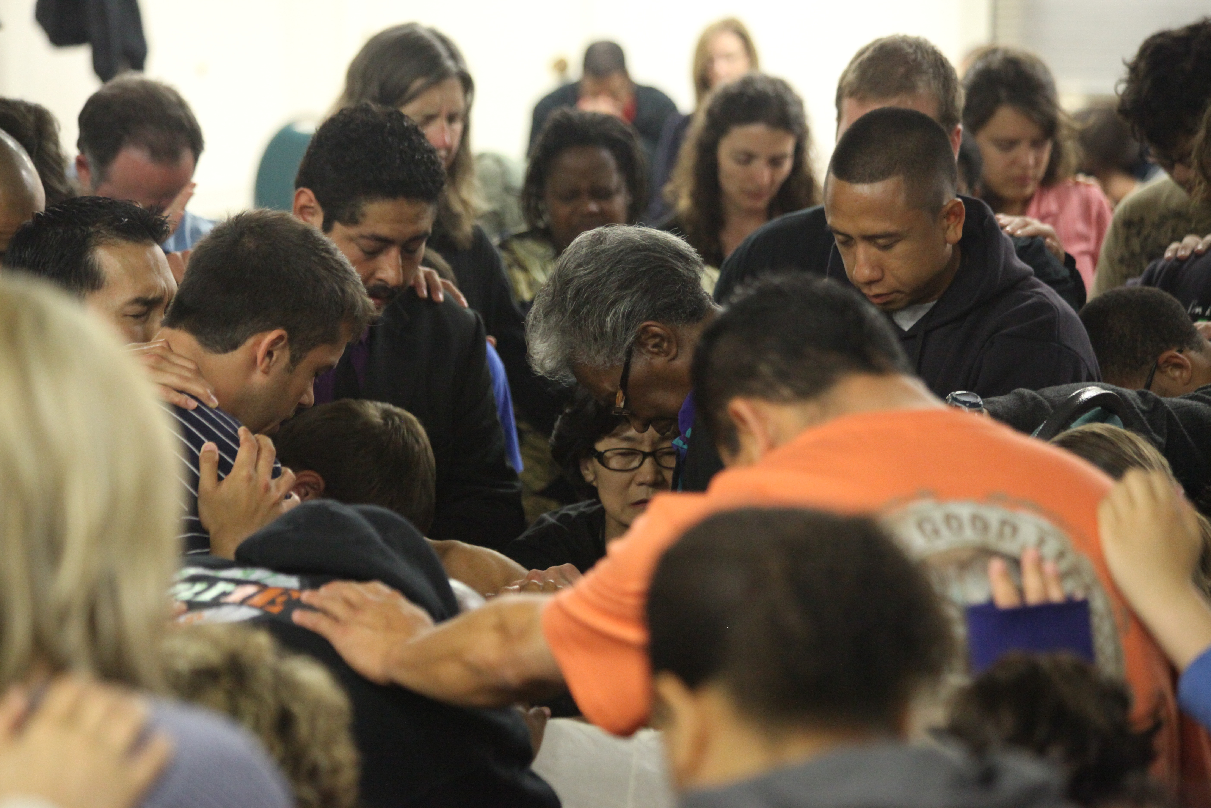

(Before continuing, give everyone the following instructions.)
Now I’d like everyone else to get up out of your seats and come forward and surround our dear brother/sister. (Encourage everyone again, if people seem reluctant to get up. They will come forward with a continued warm invitation. Sometimes you can share the following, just to help them get moving out of their seats.)

You see, in Heaven, we are going to be a close family. But now we also can get the practice of what it’s like to come together as a close family in prayer.

(Once everyone comes forward and circles the person in the chair, share the following.)

What I’m going to do is give the microphone to brother/sister (name) and ask him/her to briefly (emphasis on briefly, just 2-3 sentences) explain what we are going to pray for. Then I’m going to ask two of you to volunteer to pray. Then I will close the prayer, and we will invite another person to come forward for special prayer.

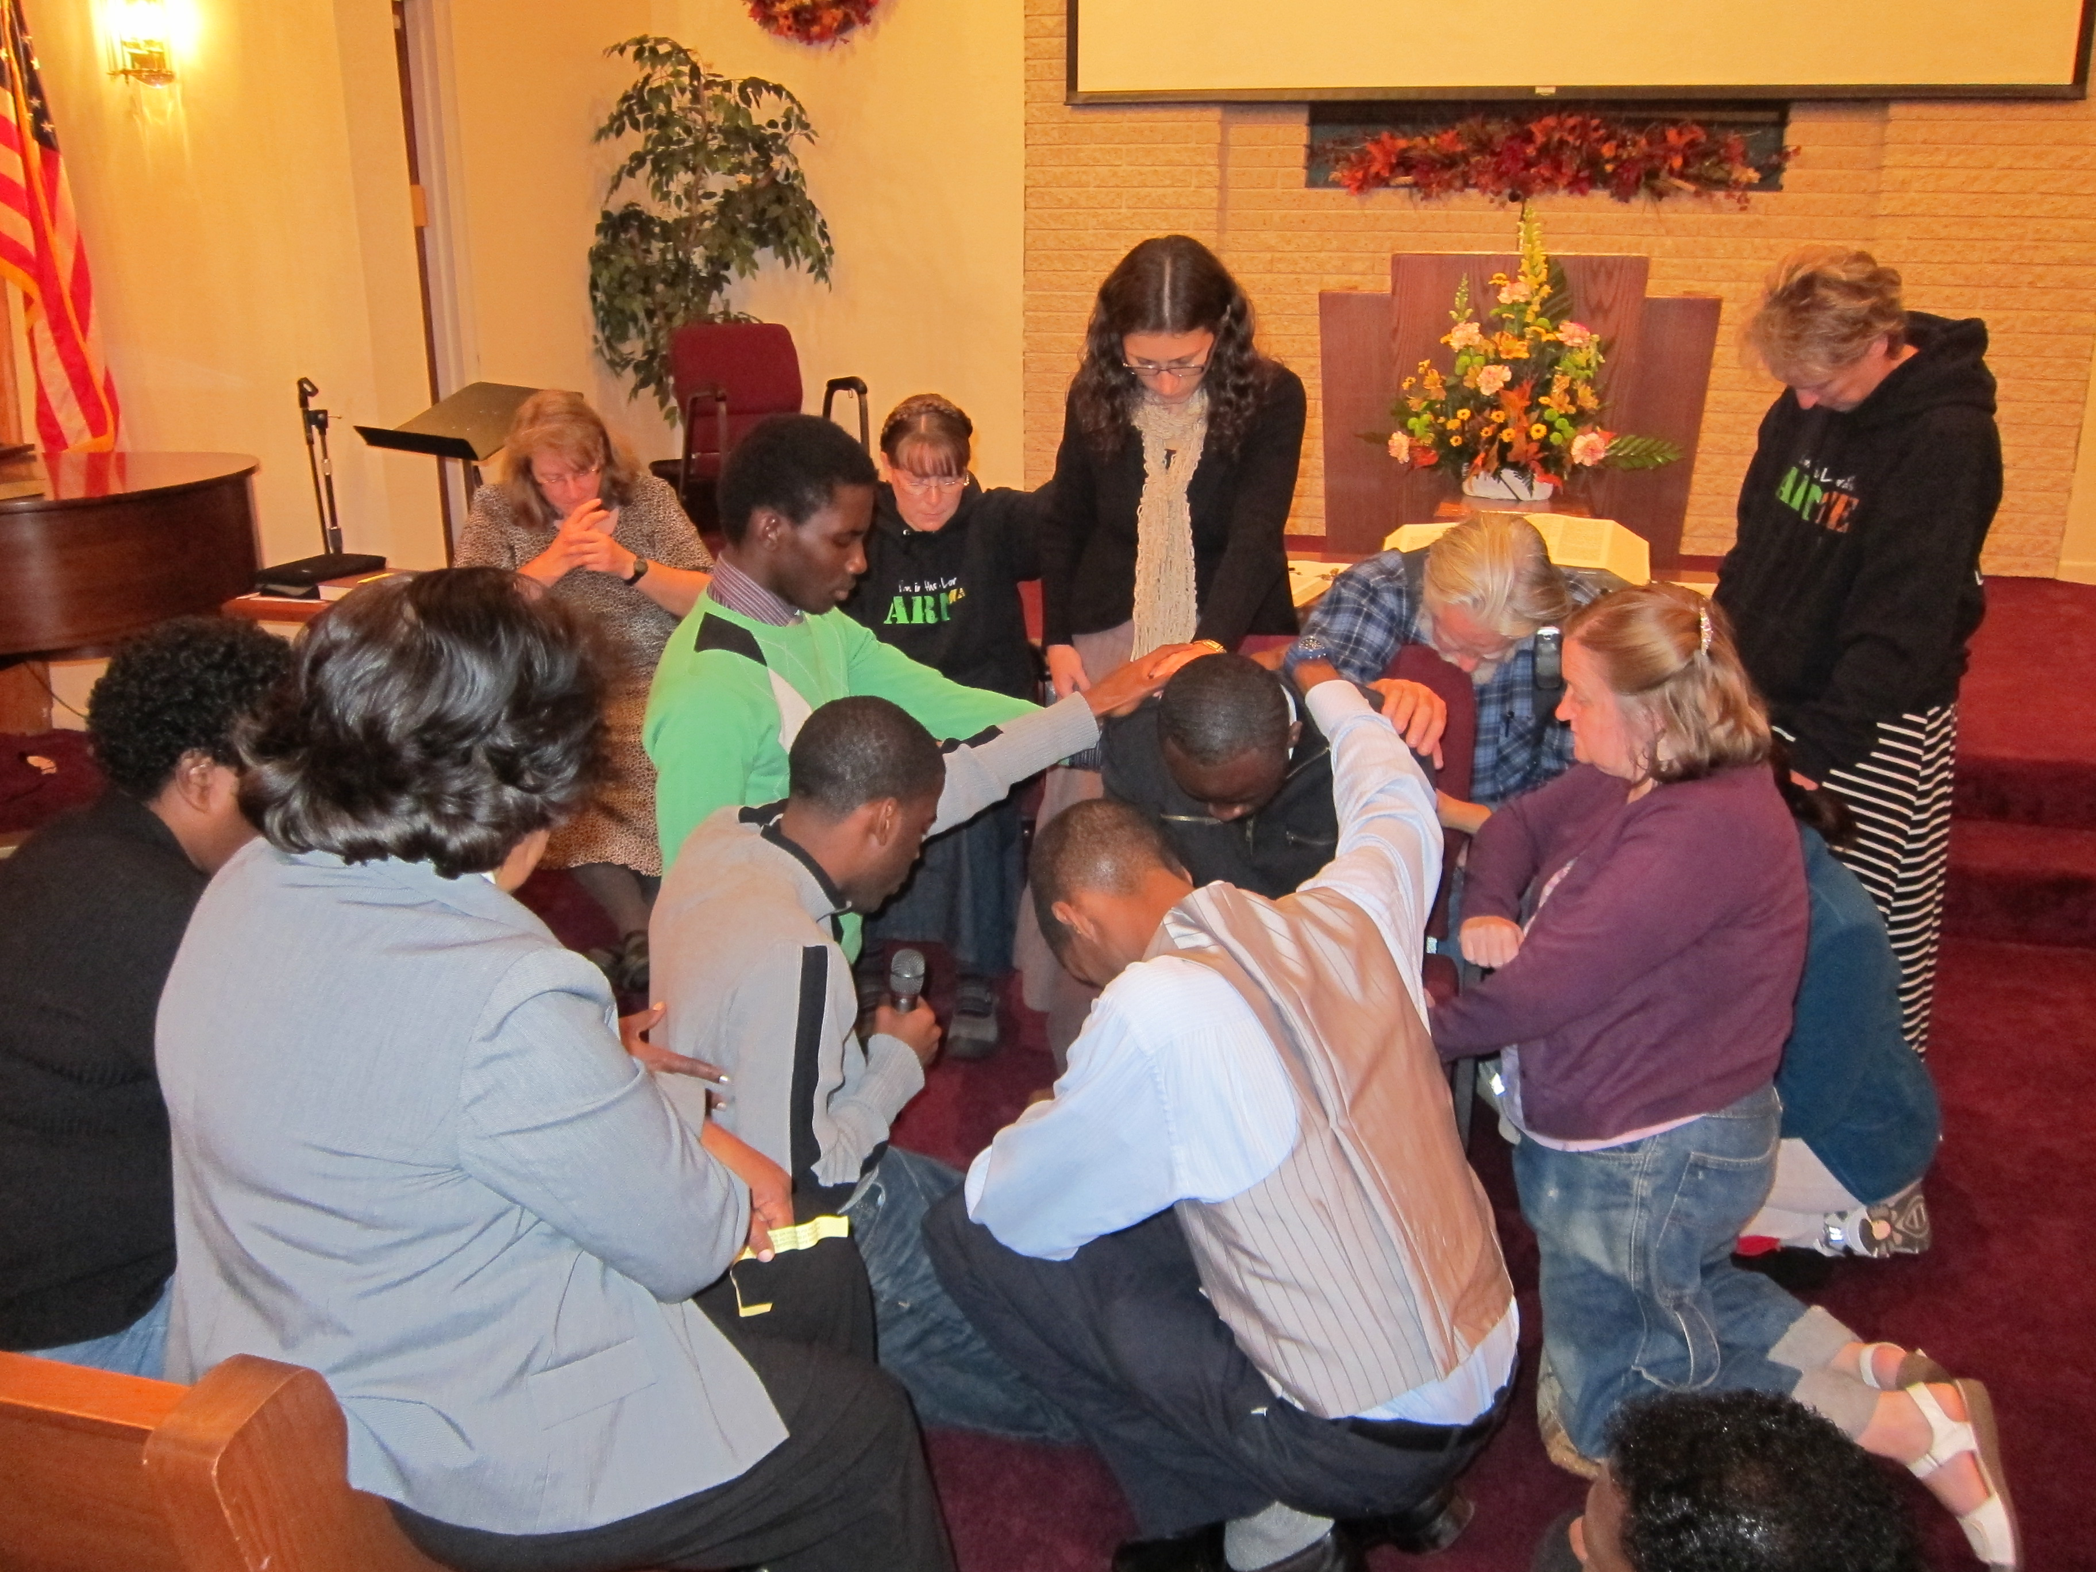

(NOTE: This prayer time should be nothing strange, but just the sharing of simple burdens and prayer requests people have. Some will share about struggling loved ones or children who aren’t in the faith that they want prayer for. Some may mention a temptation that they need victory over, or marriages that they need prayer for. This isn’t to be a time of personal explicit non-appropriate confessions. Those sins and struggles should stay between the person and God privately. This is a general time of sharing and lifting up each other in prayer. This is an opportunity as a church family to press together, pray for one another, bless one another, love each other with Christ-like, encouraging love. You might need to share the following instructions to the group that should now be pressed close together.)

It’s very important that we keep our prayers brief because we want to pray for as many of you as possible this afternoon. Remember, Satan is thrilled if he can keep us talking about our problems instead of praying about them. In fact, Ellen White writes that we are to, “Make short prayers in meetings, and lengthy prayers when [we] talk and commune with God in [our] closet... [We are to] learn to pray short and right to the point, asking for just what [we] need” (Manuscript Releases, vol. 10, p. 130).

While we want to keep our prayers short and right to the point, it’s also important that as we pray, we pray in faith. So I encourage you to claim Bible promises as we pray for each other’s requests.

Now (smiling warmly as you turn to the person seated in the chair or kneeling on the cushion), please tell us very briefly in 2 or 3 sentences, how we can pray for YOU today?

(NOTE: The person should share briefly, and then you ask those surrounding who would be willing to pray for our brother/sister. When people raise their hands to volunteer to pray, give the first person the microphone. They pray, and then pass the microphone to the second person. And then you as the leader close the prayer. Keep it to three people praying maximum, so that you can pray for more people. Sometimes more will pray on their own accord, and that’s okay, but let that be the exception and not the rule because you want to keep moving, praying for as many as possible. You also don’t want the prayer time to become tedious.

After you’ve finished praying for the first person, then invite another person to sit in the chair/kneel on the cushion, and so on, one after another, until you run out of time or until everyone who wishes to receive special prayer has been prayed for.

Feel free to interject special applicable songs or hymns throughout the time of prayer when appropriate. Songs like “He’s Able” or “There’s Power in the Blood” or “Amazing Grace” are very special after certain heart-wrenching prayer request and will add to the atmosphere of prayer fellowship and warmth.

Keep encouraging people to press close together and, if appropriate, to lay hands on one another’s shoulders during the prayer. Remember, we are seeking to build a community of prayer and love. We are going to be a family together in heaven, so it’s time we start acting like one here.

At the end of the afternoon, with the Holy Spirit’s blessing you will find that people do NOT want to leave. They’ve prayed together, cried together (don’t forget to have a Kleenex box close by), and now they feel closer as a church family than they have felt before.

However, when you feel that it’s time to close, announce that you will pray for just 2 or 3 more people and then you will be closing the program. Have a special song at the end (maybe “Showers of Blessings” again, or “To God be the Glory”). End with a brief prayer and encourage the members to continue to pray for one another in their own private prayer times until all the prayers that have been brought before the Lord today have been answered. Of course, it is our hope that the church members will enjoy the prayer time so much that they will wish to repeat it again on another Sabbath in the future.

This is truly an afternoon that your church will long remember! And may the “Circle of Blessings” that has been started continue until there is such love and unity among us that the Latter Rain outpouring that we are praying for will come! This “Circle of Blessings” – Prayer Program has already made a difference in many congregations, and we know that it will be a special day for you.)

Program Idea #2
Standing in the Gap – Prayer Program

Summary: After the “Circle of Blessings” – Prayer Program, this “Standing in the Gap” program is a nice follow up. It may be best to do at a later date. However, it’s also an alternative to the “Circle of Blessings” program if desired. This program is about uniting in prayer for a specific purpose, to see backslidden members or loved ones brought back into the church. But rather than rushing right into these requests, as is so often the case, we will encourage the following United Prayer format, which will bring greater unity to the group. And where there is Holy Spirit unity, God blesses. Consider the following verses and quotations:

“If two of you shall agree as touching anything that they shall ask, it shall be done for them of my Father which is in Heaven. For where two or three are gathered together, there am I in the midst of them.” Matt. 18:19, 20

“We are encouraged to pray for success, with the divine assurance that our prayers will be answered... The promise [of Matt. 18:19] is made on the condition that the united prayers of the church are offered, and in answer to these prayers, there may be expected a power greater than that which comes in answer to private prayer. The power given will be proportionate to the unity of the members and their love for God and for one another.” 9th Manuscript Releases (no. 748), p. 303. (Letter 32, 1903, p. 5)

“Precious promise! Do we believe it? What marvelous results would appear if the united prayers of this company were to ascend to God in living faith!” Evangelism, p. 414.

Instructions for a one-hour session of “Standing in the Gap” prayer for the Prayer Leader/coordinator:

Time Frame for 1 hour session:
Welcome/Introduction: 5 Minutes
Adoration/Praise: 10 minutes
Confession: 5-10 minutes
Supplication: 20 minutes
Thanksgiving: 5-10 minutes

Before starting an hour, or any amount of time, in united prayer, we briefly explain the format, so that the participants understand how the prayer session will proceed. As you become more experienced at leading, you will develop your own method of explaining.

It’s important that you briefly share the following, before encouraging the group to come forward to pray.

- We will pray through four prayer themes

1. Adoration and Praise: God tells us to enter His courts with praise. Thus, during this first theme, our focus in prayer will be praise and adoration. Rather than rushing right into our requests, we want to take time to worship God and reflect on the beauty of His character as revealed in His Word. Inspiration tells us that as we learn to praise God more, we will be given more blessings for which to praise Him.

2. Confession: Confession is a very important aspect of an effective prayer life. It also helps keep the channels open between us and God (Isa. 59:1, 2; 1 John 1:9). Of course, many sins are of a private nature and should be confessed only between you and God. (A time for silent confession is encouraged.) For those faults that are confessed publicly (Jas. 5:16), keep in mind that we don’t want to confess something that would cause another to stumble. (For example, specific lustful acts or thoughts, sexual sins, etc.!) In Daniel 9:4-16, we see Daniel’s example of corporate confession on behalf of God’s people. This is the type of confession that we’d like to focus on during this prayer time. However, the most important thing is to confess, silently or publicly, as the Holy Spirit convicts.

3. Supplication: Here we take God at His Word and give Him our needs, both physical and spiritual. During this prayer time, one focus will be on praying for those who may be withdrawing from church, for loved ones that we wish to see return to God, or others we want to see find Christ. God tells us to ask, seek, and knock (Matt. 7:7), and He tells us that we do not have because we do not ask (Jas. 4:2). So let’s take Him at His Word and ask! God tells us to ask large things of Him! Our greatest need is that of the Holy Spirit, so in addition to praying for missing members, our loved ones, and our community, let a yearning for the Holy Spirit be another major focus of our supplication.

We won’t take any prayer requests before the prayer session, but we encourage you to give your requests to God during our time of supplication. We will support each other in your request. Remember, the devil is happy if we merely talk about these needs and concerns, just as long as we don’t pray. So rather than talking, we are going to pray!

4. Thanksgiving: We will end with thanksgiving, praising Him for what He’s done and looking forward in faith to what He will do! “Now unto him that is able to do exceedingly abundantly ABOVE all that we ask or think, according to the power that worketh in us” (Eph. 3:20).

- Please follow the prayer leader. The leader will begin and end the prayer, as well as transition the group from one theme to the next.

- You can pray multiple times, but keep each prayer short (1 to 3 sentences) and focus on a single theme (e.g., praise, supplication, etc. or whatever the prayer leader has indicated).

- We pray conversationally. In other words, speak up in prayer whenever there is a break in the prayer time if the Holy Spirit is leading. This isn’t about praying around the circle. If you just want to listen at first, that’s fine. Only pray if the Holy Spirit prompts you to pray.

- Please speak up when you pray, so the group can hear you and agree with you in prayer as we want to avoid multiple people praying at the same time.

- Ask God to inspire your prayers. “We must not only pray in Christ's name, but by the inspiration of the Holy Spirit” (Christ’s Object Lessons, p. 147).

- Finally, as we begin, let’s press together in a close circle. It’s easier to hear each other’s prayers, and it also promotes a spirit of unity among us! And that’s what we want. Again, if we are going to be family in heaven some day, we can start acting like family here.

- I, as the prayer leader today, will start with the chorus “Turn Your Eyes upon Jesus.” I will also use a song to transition between themes. We are told, “Singing is as much an act of worship as is prayer” (Child Guidance, p. 523).

- Let’s come together and begin our time of prayer!

Note to prayer leader: Singing is not necessary; however, we have found that uniting in song, as you move from one theme to the next, is a special way to draw the group closer together in worship and praise. When thinking of songs, we recommend that you choose simple, familiar songs that most people know. This eliminates the need for hymnals and the risk of losing the attitude of reverence while participants fumble for the correct page. (For more instructions and song suggestions for the four themes, or for suggestions on how you can be a better prayer leader, please read Praying for Rain: A Mini-handbook to United Prayer which is available online in multiple languages for download.)

We encourage spending 45minutes to one hour for this time of “Standing-in-the-Gap” prayer program, but even 20 or 30 minutes can be powerful. And if the church will continue to make this time of intercession a regular habit, even if not always following the United Prayer format, they will begin to see answers to their prayers. God is just waiting to open the storehouse of heaven’s blessings upon us, but He’s waiting for us to press together in prayer. He’s waiting for us to ask!

Program Idea #3
Agape Thanksgiving Banquet – Prayer Program

Summary: This can be done following the program ideas #1 and #2 or as a separate program to foster a greater spirit of prayer and thankfulness. The purpose of this program is to pull the church together in thanksgiving for the miracles and answers to prayer that God has already given. So often we focus solely on what is going wrong or on the struggles we have in our lives, and we forget how wonderfully God has worked in the past. We forget all the blessings we have been given and all the answers to prayer that we have already received. This banquet is perfect for a Friday night vespers or a Sabbath evening program. (By the way, this has nothing to do with the American holiday; it is simply about giving THANKS to God for His blessings!)

Instructions for the
Agape Thanksgiving Banquet

Ask a team of people to help you plan a special Agape Thanksgiving Banquet. This cannot be done alone!

If possible, it’s nice to decorate the fellowship hall or a special location for this special banquet. Decorations can be simple or creative and more elegant. Don’t spend too much time on the decorations though, because the program is the most important. We want the Holy Spirit present, and the most receptive environment for the Holy Spirit to come is a thankful and surrendered heart, not an elaborate banquet hall.

Some decoration ideas might be creating a fruit platter with a wine-goblet in the center in which you place a candle. You can place this in the center of each table. If you don’t want to do a fruit platter for each table, you can just do special flowers, or a simple centerpiece on the table. (See pictures on the next page below for fruit platter and table ideas!)

If the church is not able to provide the food/fruit platters (this could be expensive in some places), then just ask the members to bring some items for a simple meal to share, perhaps fruit, bread and spreads; or soup and bread. Whatever you decide on the menu, keep it simple! Again, it’s not about the food but about the sharing time together.

Proposed Program:

- Song Service – 5 to 10 minutes
- Welcome
- Introduction

This evening we want to take some time to share our praises to God, our answered prayers, and stories of how God has worked in the past. While you eat and enjoy fellowship with those at your table, we encourage you to be thinking about a specific answered prayer that God has given you in your life recently. You can also share other testimonies or praises, but we will ask you to keep your sharing brief (no more than 3-5 minutes) so that others can share too. For now, we want you to enjoy the meal!
- Opening Prayer and blessing on the food!
- Maybe have soft music playing in the background while people eat. And if you have candles on the tables, it’s nice to turn the lights down a little for special effect.

(Note to leader: After people have been enjoying eating for maybe 30 minutes, go ahead and go back to the microphone and ask who would like to share the first testimony/blessing/or answered prayer. Again, encourage participants to keep their sharing short (2-5 minutes at most) so multiple people can share. If there’s a lag in sharing, feel free to ask your music team to lead a song here and there, or you can even have some special music pieces planned that you can intersperse throughout the program. When you feel it is time to close the program, ask the those attending to form groups of two and take a few minutes to pray for one another and for God’s blessings on their coming week. End with a closing prayer.

Below is a sample of an Agape Banquet Table. The decoration is a fruit platter with goblet in the middle holding a candle. (Goblets can often be obtained inexpensively at thrift stores or yard sales). Simple refreshments included grape juice, breads, and peanut butter, butter, jam and honey. If funds/resources don’t allow a light meal such as this, the program can just be a sharing testimony vespers. It will still be a blessing! Enjoy and be blessed!

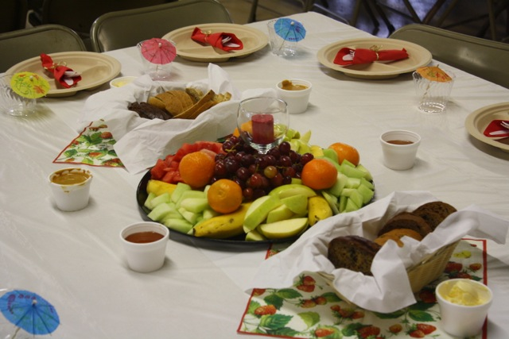

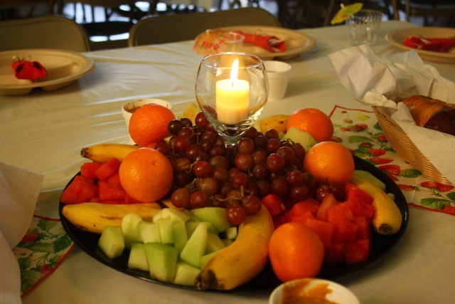

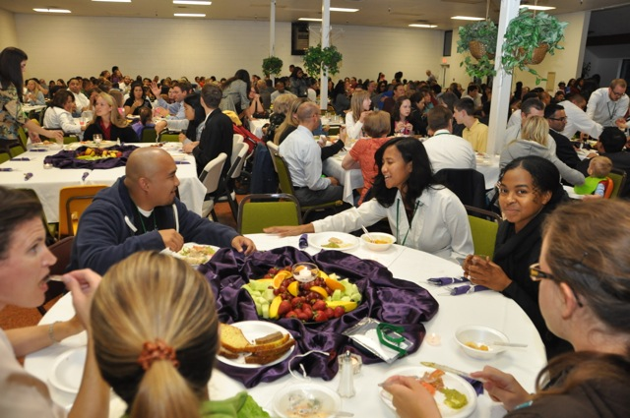

Counsels for the Church, pp. 185-186.
Counsels for the Church, p. 319.
Steps to Christ, p. 94.
Christian Service, p. 41.
Cited by Ron Clouzet in Adventism’s Greatest Need: The Outpouring of the Holy Spirit, p. 43. Originally cited by David Watson, I Believe in the Church (Grand Rapids, MI: Eerdmans, 1978), p. 166.
Christian Service, p. 277.
Selected Messages, Book 1, p. 124.
Christ’s Object Lessons, p. 146.
Pseudonym used for safety of individuals
Pseudonym used for safety of individuals
Pseudonym used for safety of individuals
This story is based on Hanh’s experience as told in an interview with Isah Young, a pastor in the Southeastern California Conference, in the United States. It is used with permission from ASAP Ministries DVD titled, Our 10 Favorites, Vol. 2, Mission Stories from Adventist Southeast Asia Projects.
Acts of the Apostles, p. 563.

